**Самостоятельная работа**

**Калькулятор краски**

Интерфейс программы:

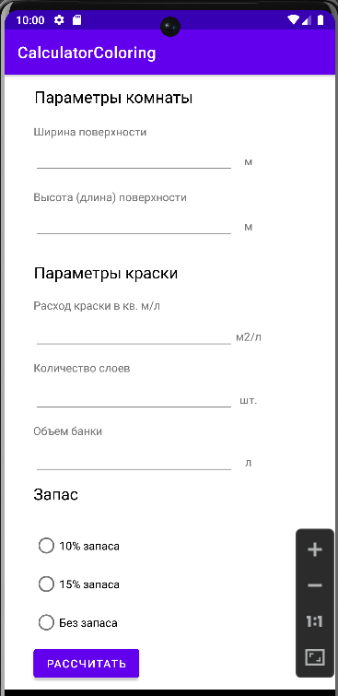 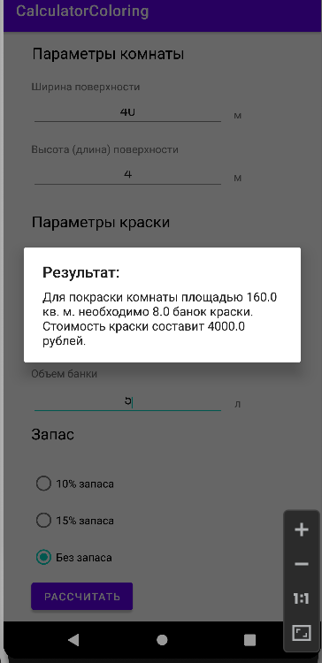

Программный код activity_main:

<?xml version="1.0" encoding="utf-8"?>  
<androidx.constraintlayout.widget.ConstraintLayout xmlns:android="http://schemas.android.com/apk/res/android"  
 xmlns:app="http://schemas.android.com/apk/res-auto"  
 xmlns:tools="http://schemas.android.com/tools"  
 android:layout_width="match_parent"  
 android:layout_height="match_parent"  
 tools:context=".MainActivity">  
  
 <EditText  
 android:id="@+id/Volume"  
 android:layout_width="250dp"  
 android:layout_height="35dp"  
 android:layout_centerVertical="true"  
 android:ellipsize="start"  
 android:gravity="center"  
 android:inputType="numberDecimal|numberSigned"  
 app:layout_constraintBottom_toBottomOf="parent"  
 app:layout_constraintEnd_toEndOf="parent"  
 app:layout_constraintHorizontal_bias="0.223"  
 app:layout_constraintStart_toStartOf="parent"  
 app:layout_constraintTop_toTopOf="parent"  
 app:layout_constraintVertical_bias="0.636" />  
  
 <TextView  
 android:id="@+id/textView5"  
 android:layout_width="wrap_content"  
 android:layout_height="wrap_content"  
 android:text="Расход краски в кв. м/л"  
 app:layout_constraintBottom_toBottomOf="parent"  
 app:layout_constraintEnd_toEndOf="parent"  
 app:layout_constraintHorizontal_bias="0.142"  
 app:layout_constraintStart_toStartOf="parent"  
 app:layout_constraintTop_toTopOf="parent"  
 app:layout_constraintVertical_bias="0.372" />  
  
 <TextView  
 android:id="@+id/textView13"  
 android:layout_width="35dp"  
 android:layout_height="35dp"  
 android:gravity="center"  
 android:text="л"  
 app:layout_constraintBottom_toBottomOf="parent"  
 app:layout_constraintEnd_toEndOf="parent"  
 app:layout_constraintHorizontal_bias="0.76"  
 app:layout_constraintStart_toStartOf="parent"  
 app:layout_constraintTop_toTopOf="parent"  
 app:layout_constraintVertical_bias="0.636" />  
  
 <TextView  
 android:id="@+id/textView12"  
 android:layout_width="35dp"  
 android:layout_height="35dp"  
 android:gravity="center"  
 android:text="шт."  
 app:layout_constraintBottom_toBottomOf="parent"  
 app:layout_constraintEnd_toEndOf="parent"  
 app:layout_constraintHorizontal_bias="0.76"  
 app:layout_constraintStart_toStartOf="parent"  
 app:layout_constraintTop_toTopOf="parent"  
 app:layout_constraintVertical_bias="0.53" />  
  
 <TextView  
 android:id="@+id/textView11"  
 android:layout_width="35dp"  
 android:layout_height="35dp"  
 android:gravity="center"  
 android:text="м2/л"  
 app:layout_constraintBottom_toBottomOf="parent"  
 app:layout_constraintEnd_toEndOf="parent"  
 app:layout_constraintHorizontal_bias="0.76"  
 app:layout_constraintStart_toStartOf="parent"  
 app:layout_constraintTop_toTopOf="parent"  
 app:layout_constraintVertical_bias="0.422" />  
  
 <TextView  
 android:id="@+id/textView7"  
 android:layout_width="wrap_content"  
 android:layout_height="wrap_content"  
 android:text="Объем банки"  
 app:layout_constraintBottom_toBottomOf="parent"  
 app:layout_constraintEnd_toEndOf="parent"  
 app:layout_constraintHorizontal_bias="0.11"  
 app:layout_constraintStart_toStartOf="parent"  
 app:layout_constraintTop_toTopOf="parent"  
 app:layout_constraintVertical_bias="0.581" />  
  
 <TextView  
 android:id="@+id/textView6"  
 android:layout_width="wrap_content"  
 android:layout_height="wrap_content"  
 android:text="Количество слоев"  
 app:layout_constraintBottom_toBottomOf="parent"  
 app:layout_constraintEnd_toEndOf="parent"  
 app:layout_constraintHorizontal_bias="0.124"  
 app:layout_constraintStart_toStartOf="parent"  
 app:layout_constraintTop_toTopOf="parent"  
 app:layout_constraintVertical_bias="0.476" />  
  
 <EditText  
 android:id="@+id/Layers"  
 android:layout_width="250dp"  
 android:layout_height="35dp"  
 android:layout_centerVertical="true"  
 android:ellipsize="start"  
 android:gravity="center"  
 android:inputType="numberDecimal|numberSigned"  
 app:layout_constraintBottom_toBottomOf="parent"  
 app:layout_constraintEnd_toEndOf="parent"  
 app:layout_constraintHorizontal_bias="0.223"  
 app:layout_constraintStart_toStartOf="parent"  
 app:layout_constraintTop_toTopOf="parent"  
 app:layout_constraintVertical_bias="0.53" />  
  
 <EditText  
 android:id="@+id/Сonsumption"  
 android:layout_width="250dp"  
 android:layout_height="35dp"  
 android:layout_centerVertical="true"  
 android:ellipsize="start"  
 android:gravity="center"  
 android:inputType="numberDecimal|numberSigned"  
 app:layout_constraintBottom_toBottomOf="parent"  
 app:layout_constraintEnd_toEndOf="parent"  
 app:layout_constraintHorizontal_bias="0.223"  
 app:layout_constraintStart_toStartOf="parent"  
 app:layout_constraintTop_toTopOf="parent"  
 app:layout_constraintVertical_bias="0.422" />  
  
 <TextView  
 android:id="@+id/textView2"  
 android:layout_width="wrap_content"  
 android:layout_height="wrap_content"  
 android:text="Ширина поверхности"  
 app:layout_constraintBottom_toBottomOf="parent"  
 app:layout_constraintEnd_toEndOf="parent"  
 app:layout_constraintHorizontal_bias="0.133"  
 app:layout_constraintStart_toStartOf="parent"  
 app:layout_constraintTop_toTopOf="parent"  
 app:layout_constraintVertical_bias="0.082" />  
  
 <TextView  
 android:id="@+id/textView3"  
 android:layout_width="wrap_content"  
 android:layout_height="wrap_content"  
 android:text="Высота (длина) поверхности"  
 app:layout_constraintBottom_toBottomOf="parent"  
 app:layout_constraintEnd_toEndOf="parent"  
 app:layout_constraintHorizontal_bias="0.163"  
 app:layout_constraintStart_toStartOf="parent"  
 app:layout_constraintTop_toTopOf="parent"  
 app:layout_constraintVertical_bias="0.191" />  
  
 <TextView  
 android:id="@+id/textView"  
 android:layout_width="wrap_content"  
 android:layout_height="wrap_content"  
 android:textSize="20sp"  
 android:textColor="@color/black"  
 android:text="Параметры комнаты"  
 app:layout_constraintBottom_toBottomOf="parent"  
 app:layout_constraintEnd_toEndOf="parent"  
 app:layout_constraintHorizontal_bias="0.173"  
 app:layout_constraintStart_toStartOf="parent"  
 app:layout_constraintTop_toTopOf="parent"  
 app:layout_constraintVertical_bias="0.019" />  
  
 <EditText  
 android:id="@+id/HeightRoom"  
 android:layout_width="250dp"  
 android:layout_height="35dp"  
 android:layout_centerVertical="true"  
 android:ellipsize="start"  
 android:gravity="center"  
 android:inputType="numberDecimal|numberSigned"  
 app:layout_constraintBottom_toBottomOf="parent"  
 app:layout_constraintEnd_toEndOf="parent"  
 app:layout_constraintHorizontal_bias="0.223"  
 app:layout_constraintStart_toStartOf="parent"  
 app:layout_constraintTop_toTopOf="parent"  
 app:layout_constraintVertical_bias="0.234" />  
  
 <TextView  
 android:id="@+id/textView4"  
 android:layout_width="wrap_content"  
 android:layout_height="wrap_content"  
 android:textSize="20sp"  
 android:text="Параметры краски"  
 android:textColor="@color/black"  
 app:layout_constraintBottom_toBottomOf="parent"  
 app:layout_constraintEnd_toEndOf="parent"  
 app:layout_constraintHorizontal_bias="0.158"  
 app:layout_constraintStart_toStartOf="parent"  
 app:layout_constraintTop_toTopOf="parent"  
 app:layout_constraintVertical_bias="0.315" />  
  
 <EditText  
 android:id="@+id/WidthRoom"  
 android:layout_width="250dp"  
 android:layout_height="35dp"  
 android:layout_centerVertical="true"  
 android:ellipsize="start"  
 android:gravity="center"  
 android:inputType="numberDecimal|numberSigned"  
 app:layout_constraintBottom_toBottomOf="parent"  
 app:layout_constraintEnd_toEndOf="parent"  
 app:layout_constraintHorizontal_bias="0.223"  
 app:layout_constraintStart_toStartOf="parent"  
 app:layout_constraintTop_toTopOf="parent"  
 app:layout_constraintVertical_bias="0.123" />  
  
 <TextView  
 android:id="@+id/textView9"  
 android:layout_width="35dp"  
 android:layout_height="35dp"  
 android:gravity="center"  
 android:text="м"  
 app:layout_constraintBottom_toBottomOf="parent"  
 app:layout_constraintEnd_toEndOf="parent"  
 app:layout_constraintHorizontal_bias="0.76"  
 app:layout_constraintStart_toStartOf="parent"  
 app:layout_constraintTop_toTopOf="parent"  
 app:layout_constraintVertical_bias="0.123" />  
  
 <TextView  
 android:id="@+id/textView10"  
 android:layout_width="35dp"  
 android:layout_height="35dp"  
 android:gravity="center"  
 android:text="м"  
 app:layout_constraintBottom_toBottomOf="parent"  
 app:layout_constraintEnd_toEndOf="parent"  
 app:layout_constraintHorizontal_bias="0.76"  
 app:layout_constraintStart_toStartOf="parent"  
 app:layout_constraintTop_toTopOf="parent"  
 app:layout_constraintVertical_bias="0.234" />  
  
 <RadioGroup  
 android:layout_width="200dp"  
 android:layout_height="143dp"  
 app:layout_constraintBottom_toBottomOf="parent"  
 app:layout_constraintEnd_toEndOf="parent"  
 app:layout_constraintHorizontal_bias="0.17"  
 app:layout_constraintStart_toStartOf="parent"  
 app:layout_constraintTop_toTopOf="parent"  
 app:layout_constraintVertical_bias="0.904">  
  
 <RadioButton  
 android:id="@+id/radio1"  
 android:layout_width="wrap_content"  
 android:layout_height="wrap_content"  
 android:layout_weight="1"  
 android:text="10% запаса" />  
  
 <RadioButton  
 android:id="@+id/radio2"  
 android:layout_width="wrap_content"  
 android:layout_height="wrap_content"  
 android:layout_weight="1"  
 android:text="15% запаса" />  
  
 <RadioButton  
 android:id="@+id/radio3"  
 android:layout_width="wrap_content"  
 android:layout_height="wrap_content"  
 android:layout_weight="1"  
 android:text="Без запаса" />  
 </RadioGroup>  
  
 <TextView  
 android:id="@+id/textView8"  
 android:layout_width="wrap_content"  
 android:layout_height="wrap_content"  
 android:textSize="20sp"  
 android:text="Запас"  
 android:textColor="@color/black"  
 app:layout_constraintBottom_toBottomOf="parent"  
 app:layout_constraintEnd_toEndOf="parent"  
 app:layout_constraintHorizontal_bias="0.101"  
 app:layout_constraintStart_toStartOf="parent"  
 app:layout_constraintTop_toTopOf="parent"  
 app:layout_constraintVertical_bias="0.688" />  
  
 <Button  
 android:id="@+id/TotalButton"  
 android:onClick="onButtonClick"  
 android:layout_width="wrap_content"  
 android:layout_height="wrap_content"  
 android:text="Рассчитать"  
 app:layout_constraintBottom_toBottomOf="parent"  
 app:layout_constraintEnd_toEndOf="parent"  
 app:layout_constraintHorizontal_bias="0.129"  
 app:layout_constraintStart_toStartOf="parent"  
 app:layout_constraintTop_toTopOf="parent"  
 app:layout_constraintVertical_bias="0.988" />  
  
  
  
</androidx.constraintlayout.widget.ConstraintLayout>

Программный код MainActivity:

package com.example.calculatorcoloring;  
  
import androidx.appcompat.app.AppCompatActivity;  
  
import androidx.appcompat.app.AlertDialog;  
import androidx.appcompat.app.AppCompatActivity;  
  
import android.os.Bundle;  
import android.view.View;  
import android.content.Intent;  
import android.os.Bundle;  
import android.view.View;  
import android.widget.EditText;  
import android.widget.RadioButton;  
import android.widget.Toast;  
  
public class MainActivity extends AppCompatActivity {  
  
 @Override  
 protected void onCreate(Bundle savedInstanceState) {  
 super.onCreate(savedInstanceState);  
 setContentView(R.layout.*activity_main*);  
 }  
  
 public void onButtonClick(View view) {  
 EditText widthE = findViewById(R.id.*WidthRoom*);  
 EditText heightE = findViewById(R.id.*HeightRoom*);  
 EditText consupE = findViewById(R.id.*Сonsumption*);  
 EditText layersE = findViewById(R.id.*Layers*);  
 EditText volumeE = findViewById(R.id.*Volume*);  
 RadioButton radioButton1 = findViewById(R.id.*radio1*);  
 RadioButton radioButton2 = findViewById(R.id.*radio2*);  
 RadioButton radioButton3 = findViewById(R.id.*radio3*);  
  
 double width = Double.*parseDouble*(widthE.getText().toString());  
 double height = Double.*parseDouble*(heightE.getText().toString());  
 int layers = Integer.*parseInt*(layersE.getText().toString());  
 double consup = Double.*parseDouble*(consupE.getText().toString());  
 double volume = Double.*parseDouble*(volumeE.getText().toString());  
  
 double surface = width * height;  
  
 double totalPaint = surface * layers / consup;  
  
 double paintReverse = 1.0;  
 double canVolume = 0;  
  
 if (radioButton3.isChecked()) {  
 paintReverse = 1.0;  
 } else if (radioButton2.isChecked()){  
 paintReverse = 1.1;  
 } else {  
 paintReverse = 1.15;  
 }  
  
 canVolume = Math.*ceil*(totalPaint * paintReverse / volume);  
 double paintCost = canVolume * volume * 100;  
  
 AlertDialog.Builder dialog = new AlertDialog.Builder(MainActivity.this);  
 dialog.setTitle("Результат:");  
 dialog.setMessage("Для покраски комнаты площадью " + surface + " кв. м. необходимо " + canVolume + " банок краски. Стоимость краски составит " + paintCost + " рублей.");  
 dialog.show();  
  
 }  
}

Ссылка на GOGS: http://10.0.10.250:3000/IvshinAndrey/CalculatorColor.git